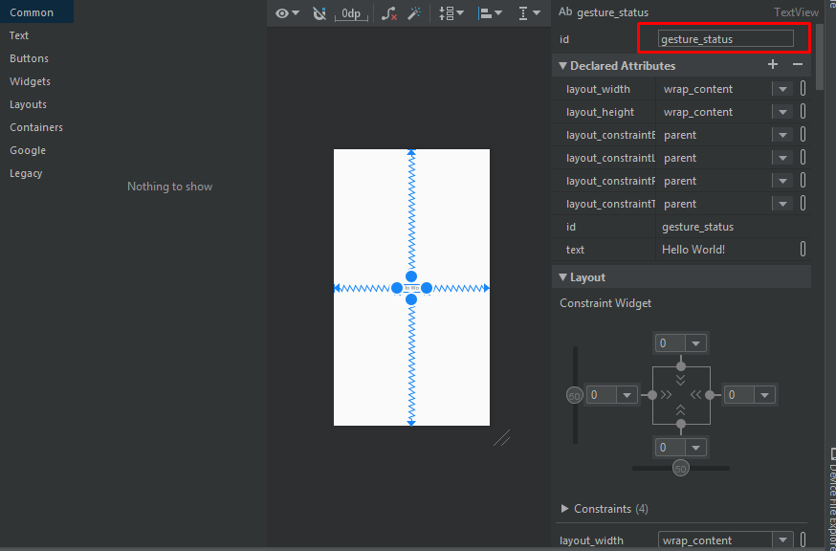

|  |
| --- |
| package agis.ghost.pertemuan_8  import androidx.appcompat.app.AppCompatActivity  import android.os.Bundle  import android.view.GestureDetector  import android.view.MotionEvent  import androidx.core.view.GestureDetectorCompat  import com.vauzan.pertemuan_8.R  import kotlinx.android.synthetic.main.activity_main.*  class MainActivity() : AppCompatActivity(),GestureDetector.OnGestureListener,  GestureDetector.OnDoubleTapListener {  var gDetector: GestureDetectorCompat?=null  override fun onCreate(savedInstanceState: Bundle?) {  super.onCreate(savedInstanceState)  setContentView(R.layout.activity_main)  //membuat class turunan GestureDetectorCompat  this.gDetector = GestureDetectorCompat (this, this)  gDetector?.setOnDoubleTapListener(this)  }  //mencegah sentuhan/tap dan meneruskan ke intance GestureDetectorCompat  override fun onTouchEvent(event: MotionEvent?): Boolean {  this.gDetector?.onTouchEvent (event)  return super.onTouchEvent(event)  }  //implementasi untuk ketukan kebawah atau ondown  override fun onDown(event: MotionEvent):Boolean{  gesture_status.text="onDown"  return true  }  //  override fun onFling(event1: MotionEvent,  event2: MotionEvent, velocityX: Float, velocityY: Float): Boolean {  gesture_status.text="onFling"  return true  }  //  override fun onLongPress(event: MotionEvent) {  gesture_status.text= "onLongPress"  }  //  override fun onScroll(  event1: MotionEvent,  event2: MotionEvent,  distanceX: Float,  distanceY: Float): Boolean {  gesture_status.text="onScroll"  return true  }  //  override fun onShowPress(event: MotionEvent) {  gesture_status.text="onShowPress"  }  //  override fun onSingleTapUp(event: MotionEvent): Boolean {  gesture_status.text="onSingleTapUp"  return true  }  //  override fun onDoubleTap(event: MotionEvent): Boolean {  gesture_status.text="onDoubleTap"  return true  }  override fun onDoubleTapEvent(event: MotionEvent): Boolean {  gesture_status.text="onDoubleTapEvent"  return true  }  override fun onSingleTapConfirmed(event: MotionEvent): Boolean {  gesture_status.text="onSingleTapConfirmed"  return true  }  } |